**Assignment 2 : Retrieve data using join with where clause**

**--------------------------------------------------------------------------------------------------------------------------**

**Sample table1: salesman**

**-salesman_id**

**-name**

**-city**

**-commission**

**Sample table2: customer**

**-customer_id**

**-cust_name**

**-city**

**-grade**

**-salesman_id**

**Sample table3: orders**

**-ord_no**

**-purch_amt**

**-ord_date**

**-customer_id**

**-salesman_id**

**CREATING SALESMAN TABLE**

CREATE TABLE [SALESMAN]

(salesman_id INT PRIMARY KEY IDENTITY(5001,1),

NAME varchar(50) NOT null,

city varchar(50) Not null,

commission float Not null

)

INSERT INTO SALESMAN VALUES ('James Hoog','New York', 0.15),( 'Nail Knite','Paris', 0.13),('Pit Alex','London',0.11),('Mc Lyon','Paris', 0.14),('Paul Adam ','Rome', 0.13),('Lauson Hen','San Jose',0.12)

SELECT * FROM SALESMAN

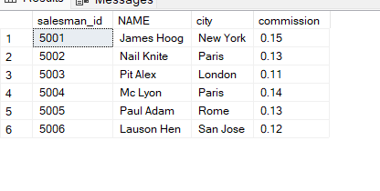

--**CREATING CUSTOMER TABLE**

CREATE TABLE [CUSTOMER]

( customer_id INT PRIMARY KEY IDENTITY(3001,1),

cust_name NCHAR(50) NOT NULL,

city NCHAR(50) NOT NULL,

grade INT NULL,

salesman_id INT NOT NULL

)

DROP TABLE CUSTOMER

SELECT * FROM CUSTOMER

select * from SALESMAN

INSERT INTO CUSTOMER VALUES ('Nick Rimando' , 'New York', 100,5001),('Brad Davis','New York', 200 ,5001),('Graham Zusi','California', 200 ,5002),('Julian Green',' London' , 300,5002),('Fabian Johnson','Paris' ,300, 5004),(' Geoff Cameron ', 'Berlin' ,100, 5006),('Jozy Altidor','Moscow ',200, 5005), ('Brad Guzan','London',NULL,5003)

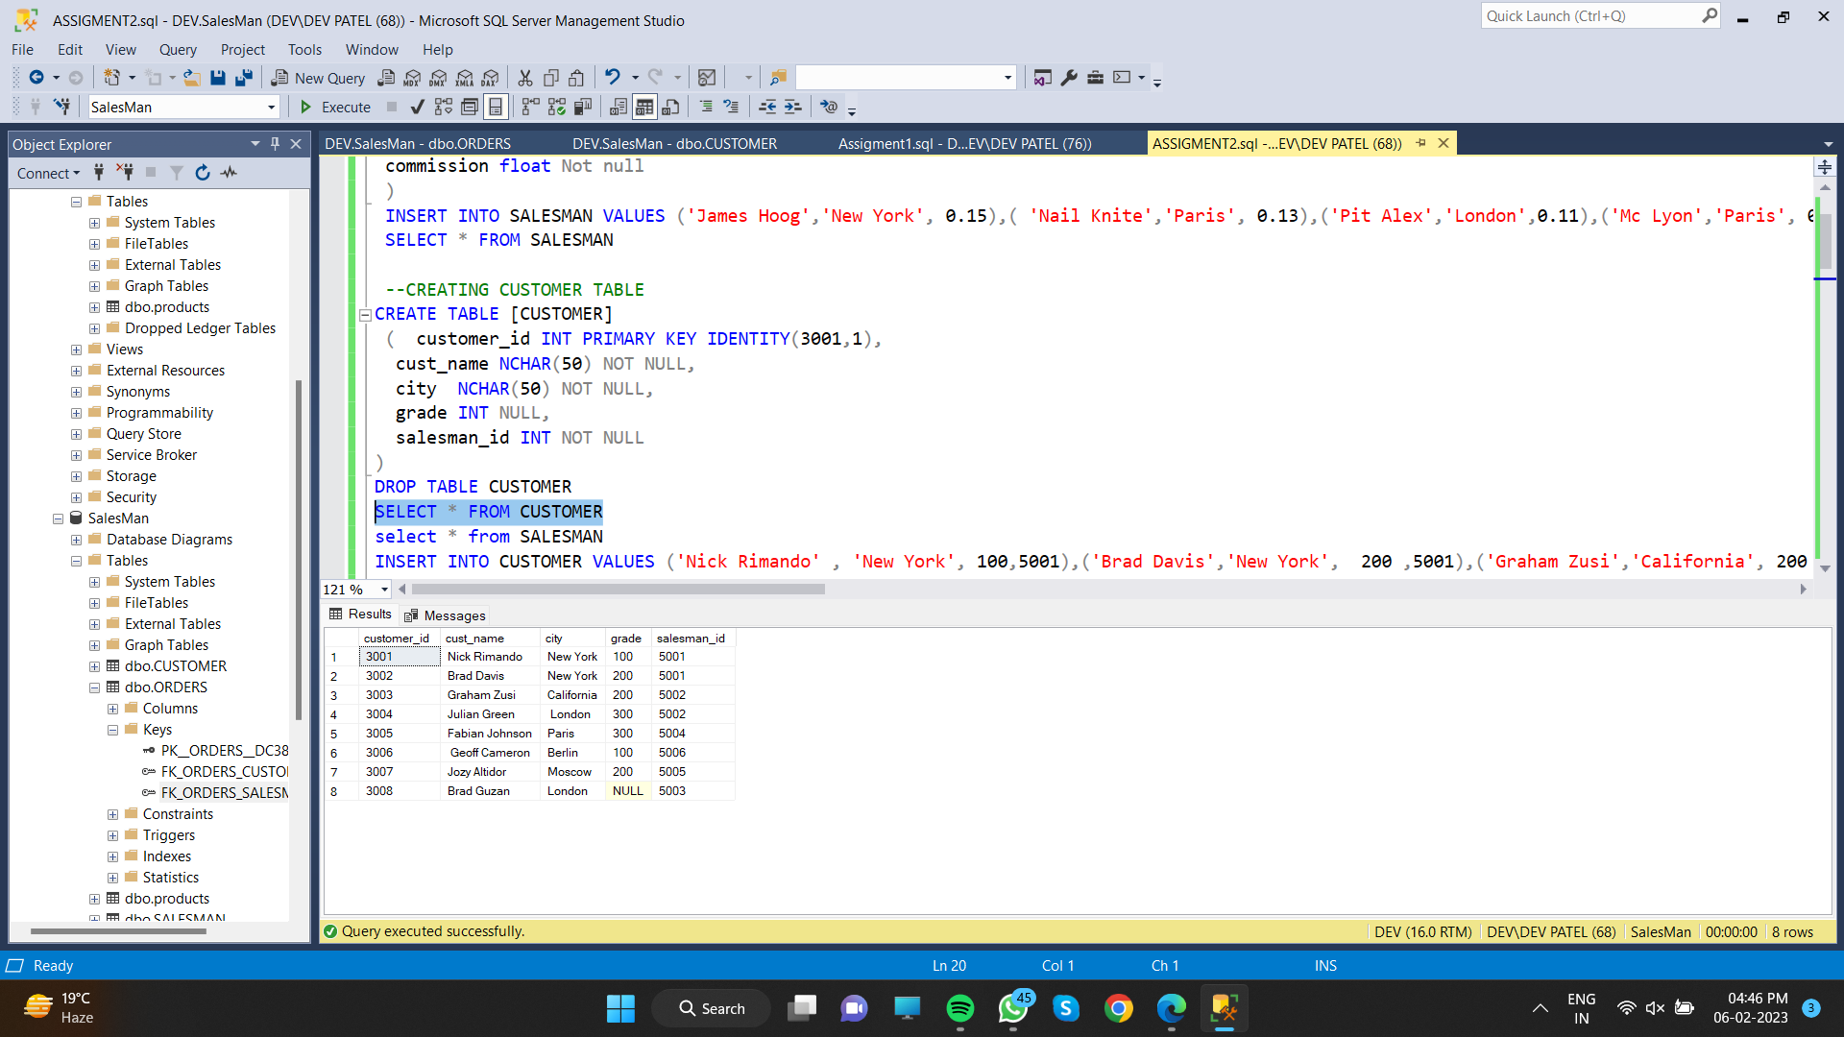

**CREATING ORDER TABLE**

CREATE TABLE [ORDERS]

(ord_no INT PRIMARY KEY IDENTITY(70001,1),

purch_amt FLOAT NOT NULL,

ord_date DATE NOT NULL,

customer_id INT NOT NULL,

salesman_id INT NOT NULL

)

SELECT * FROM [ORDERS]

TRUNCATE TABLE [ORDERS]

INSERT INTO ORDERS VALUES (150.5 ,'2012-10-05' ,3003,5002),(270.65,'2012-09-10',3008 ,5003),( 65.26 ,'2012-10-05 ', 3001,5001),(110.5,'2012-08-17 ' ,3006 , 5006),(948.5,'2012-09-10',3003,5002),(2400.6 ,'2012-07-27 ', 3002 , 5001),( 5760,'2012-09-10',3001, 5001),(1983.43 ,' 2012-10-10 ' ,3005, 5004),(2480.4 ,'2012-10-10',3006, 5006),(250.45 ,'2012-06-27',3004, 5002),(75.29,'2012-08-17',3007,5005),(3045.6 ,'2012-04-25',3001 ,5001)

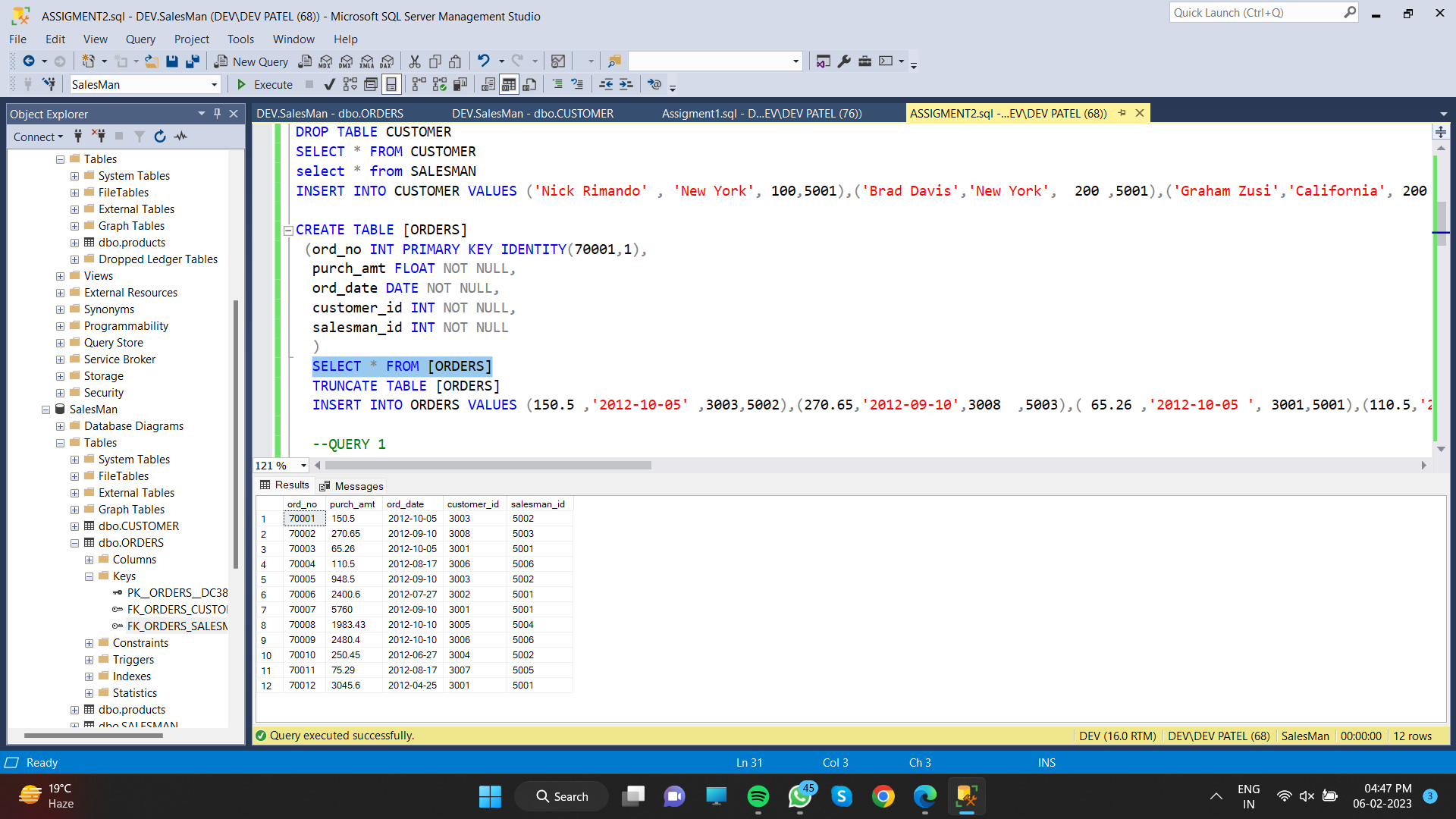

**1. write a SQL query to find the salesperson and customer who reside in the same city.**

**Return Salesman, cust_name and city**

SELECT name as salesman_name,cust_name,s.city AS CITY FROM SALESMAN s join CUSTOMER c on s.city=c.city order by city desc

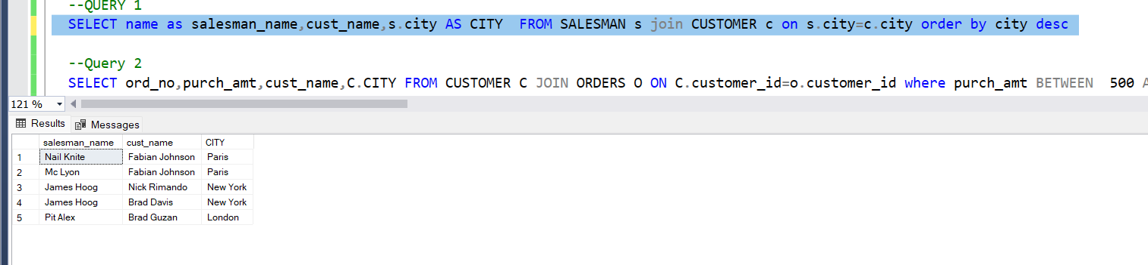

**2. write a SQL query to find those orders where the order amount exists between 500**

**and 2000. Return ord_no, purch_amt, cust_name, city**

SELECT ord_no,purch_amt,cust_name,C.CITY FROM CUSTOMER C JOIN ORDERS O ON C.customer_id=o.customer_id where purch_amt BETWEEN 500 AND 2000

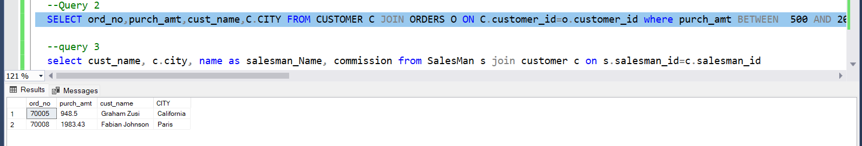

**3. write a SQL query to find the salesperson(s) and the customer(s) he represents.**

**Return Customer Name, city, Salesman, commission**

select cust_name, c.city, name as salesman_Name, commission from SalesMan s join customer c on s.salesman_id=c.salesman_id

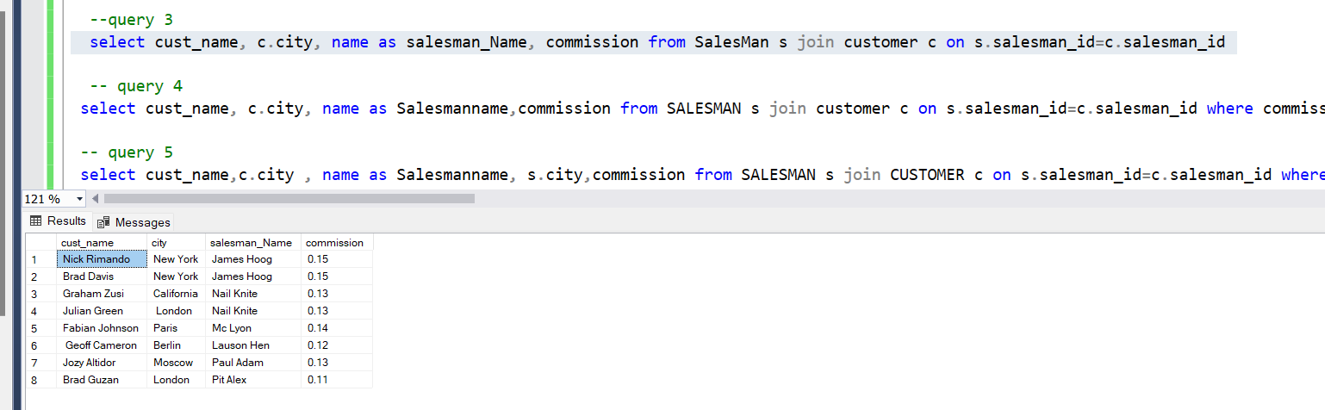

**4. write a SQL query to find salespeople who received commissions of more than 12**

**percent from the company. Return Customer Name, customer city, Salesman,**

**Commission.**

select cust_name, c.city, name as Salesmanname,commission from SALESMAN s join customer c on s.salesman_id=c.salesman_id where commission > 0.12

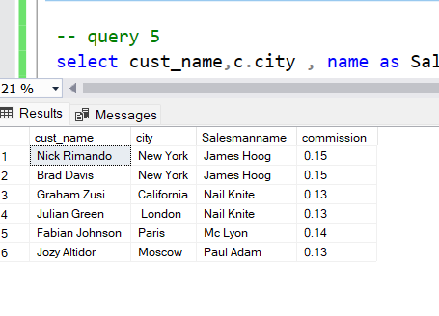

**5. write a SQL query to locate those salespeople who do not live in the same city where**

**their customers live and have received a commission of more than 12% from the**

**company. Return Customer Name, customer city, Salesman, salesman city,**

**Commission**

select cust_name,c.city , name as Salesmanname, s.city,commission from SALESMAN s join CUSTOMER c on s.salesman_id=c.salesman_id where s.city!=c.city and commission > 0.12

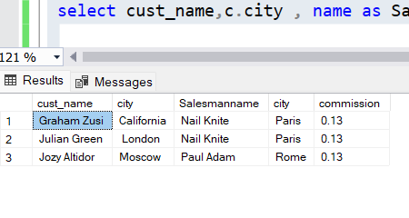

**6. write a SQL query to find the details of an order. Return ord_no, ord_date,**

**purch_amt, Customer Name, grade, Salesman, commission**

select ord_no, ord_date,purch_amt, cust_name, grade, name as Salesmanname, commission from orders o join customer c on c.customer_id=o.customer_id join salesman s on s.salesman_id=o.salesman_id

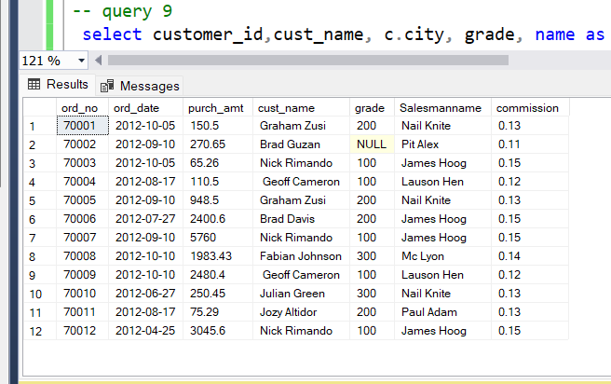

**7. Write a SQL statement to join the tables salesman, customer and orders so that the**

**same column of each table appears once and only the relational rows are returned.**

SELECT s.salesman_id,o.purch_amt,o.ord_date, c.customer_id, o.ord_no,c.cust_name,c.city,c.grade,s.name,s.commission

FROM orders AS o ,customer AS c, salesman as s

where o.customer_id = c.customer_id and o.salesman_id = s.salesman_id and c.city = s.city;

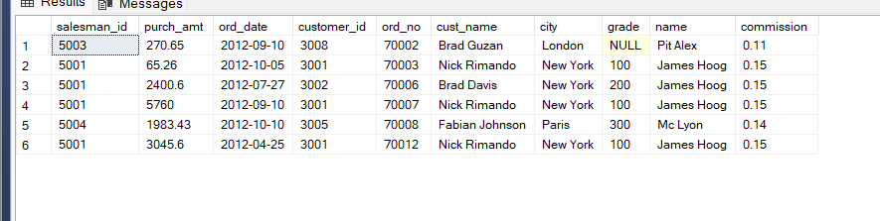

**8. write a SQL query to display the customer name, customer city, grade, salesman,**

**salesman city. The results should be sorted by ascending customer_id.**

select cust_name,c.city, grade, name as Salesmanname, s.city from SalesMan s join customer c on s.salesman_id=c.salesman_id order by c.customer_id asc

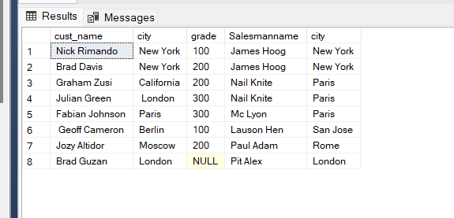

**9. write a SQL query to find those customers with a grade less than 300. Return**

**cust_name, customer city, grade, Salesman, salesmancity. The result should be**

**ordered by ascending customer_id.**

select customer_id,cust_name, c.city, grade, name as Salesmanname, s.city from salesman s join customer c on s.salesman_id=c.salesman_id where c.grade<300 order by customer_id asc

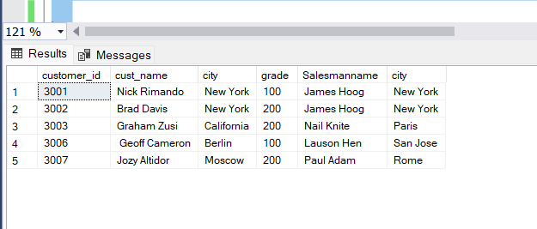

**10. Write a SQL statement to make a report with customer name, city, order number,**

**order date, and order amount in ascending order according to the order date to**

**determine whether any of the existing customers have placed an order or not**

SELECT a.cust_name,a.city, b.ord_no,b.ord_date,b.purch_amt AS "Order Amount" FROM customer a JOIN orders b ON a.customer_id=b.customer_id order by b.ord_date;

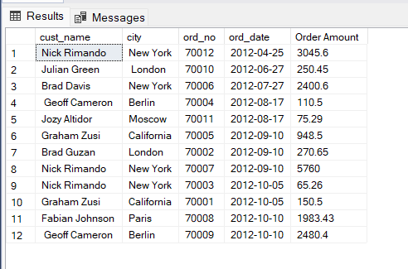

**11. Write a SQL statement to generate a report with customer name, city, order number,**

**order date, order amount, salesperson name, and commission to determine if any of**

**the existing customers have not placed orders or if they have placed orders through**

**their salesman or by themselves**

select a.cust_name,a.city, b.ord_no,b.ord_date,b.purch_amt AS "Order Amount", name as salesmanname,commission from orders b join customer a on b.customer_id=a.customer_id join salesman s on b.salesman_id=s.salesman_id

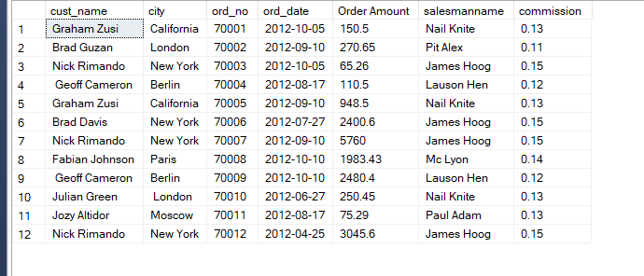

**12. Write a SQL statement to generate a list in ascending order of salespersons who**

**work either for one or more customers or have not yet joined any of the customers**

SELECT a.cust_name,a.city,a.grade, B.SALESMAN_ID,b.name AS "Salesman", b.city FROM customer a JOIN salesman b ON b.salesman_id=a.salesman_id ORDER BY b.salesman_id;

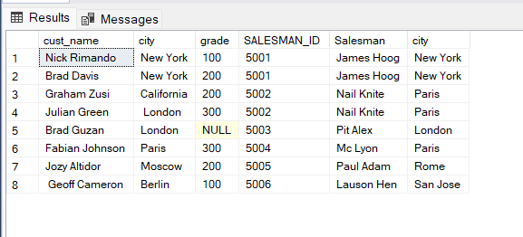

**13. write a SQL query to list all salespersons along with customer name, city, grade,**

**order number, date, and amount.**

SELECT a.cust_name,a.city,a.grade, b.name AS "Salesman", c.ord_no, c.ord_date, c.purch_amt FROM customer a RIGHT OUTER JOIN salesman b ON b.salesman_id=a.salesman_id RIGHT OUTER JOIN orders c ON c.customer_id=a.customer_id;

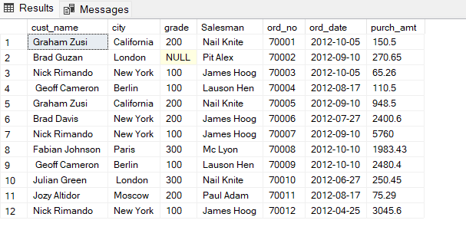

**14. Write a SQL statement to make a list for the salesmen who either work for one or**

**more customers or yet to join any of the customers. The customer may have placed,**

**either one or more orders on or above order amount 2000 and must have a grade, or**

**he may not have placed any order to the associated supplier.**

SELECT a.cust_name,a.city,a.grade, b.name AS "Salesman", c.ord_no, c.ord_date, c.purch_amt FROM customer a RIGHT OUTER JOIN salesman b ON b.salesman_id=a.salesman_id LEFT OUTER JOIN orders c ON c.customer_id=a.customer_id WHERE c.purch_amt>=2000AND a.grade IS NOT NULL;

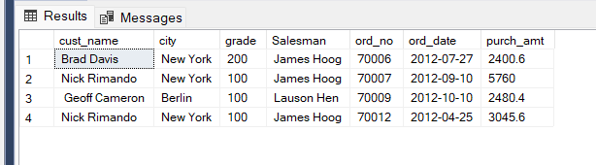

**15. Write a SQL statement to generate a list of all the salesmen who either work for one**

**or more customers or have yet to join any of them. The customer may have placed**

**one or more orders at or above order amount 2000, and must have a grade, or he**

**may not have placed any orders to the associated supplier.**

SELECT a.cust_name,a.city,a.grade, b.name AS "Salesman", c.ord_no, c.ord_date, c.purch_amt FROM customer a RIGHT OUTER JOIN salesman b ON b.salesman_id=a.salesman_id LEFT OUTER JOIN orders c ON c.customer_id=a.customer_id WHERE c.purch_amt>=2000AND a.grade IS NOT NULL;



**16. Write a SQL statement to generate a report with the customer name, city, order no.**

**order date, purchase amount for only those customers on the list who must have a**

**grade and placed one or more orders or which order(s) have been placed by the**

**customer who neither is on the list nor has a grade.**

SELECT a.cust_name,a.city, b.ord_no,b.ord_date,b.purch_amt AS "Order Amount" FROM customer a FULL OUTER JOIN orders b ON a.customer_id=b.customer_id WHERE a.grade IS NOT NULL;

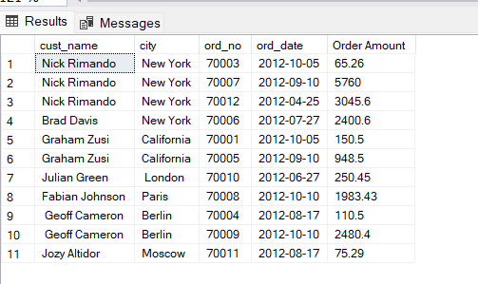

**17. Write a SQL query to combine each row of the salesman table with each row of the**

**customer table**

SELECT s.name AS "Salesman",c.cust_name AS "Customer Name" FROM salesman s CROSS JOIN customer c;

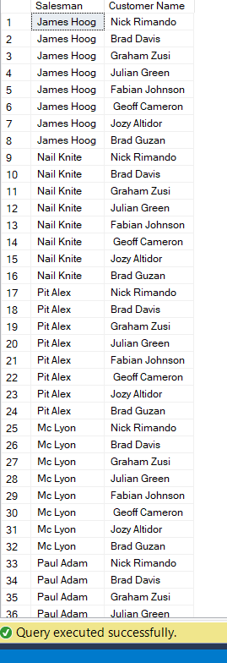

**18. Write a SQL statement to create a Cartesian product between salesperson and**

**customer, i.e. each salesperson will appear for all customers and vice versa for that**

**salesperson who belongs to that city**

SELECT s.name AS "Salesman",c.cust_name AS "Customer Name" FROM salesman s CROSS JOIN customer c WHERE s.city IS NOT NULL;

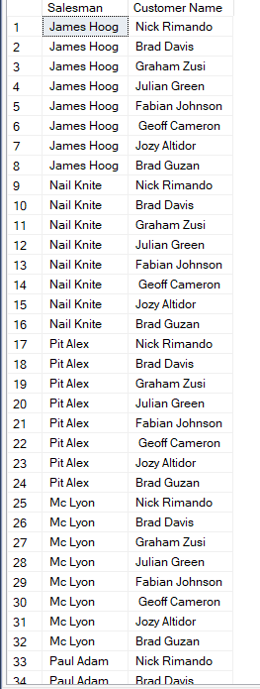

**19. Write a SQL statement to create a Cartesian product between salesperson and**

**customer, i.e. each salesperson will appear for every customer and vice versa for**

**those salesmen who belong to a city and customers who require a grade**

SELECT s.name AS "Salesman", c.cust_name AS "Customer Name" FROM salesman s CROSS JOIN customer c WHERE s.city IS NOT NULL AND c.grade IS NOT NULL;

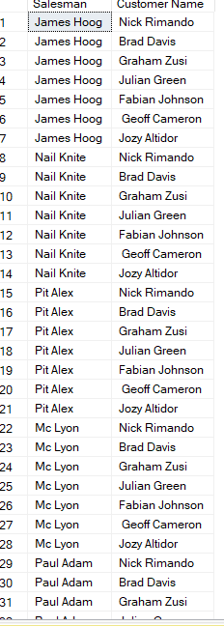

**20. Write a SQL statement to make a Cartesian product between salesman and**

**customer i.e. each salesman will appear for all customers and vice versa for those**

**salesmen who must belong to a city which is not the same as his customer and the**

**customers should have their own grade**

SELECT s.name AS "Salesman",c.cust_name AS "Customer Name" FROM salesman s CROSS JOIN customer c WHERE s.city IS NOT NULL AND s.city != c.city AND c.grade IS NOT NULL;

